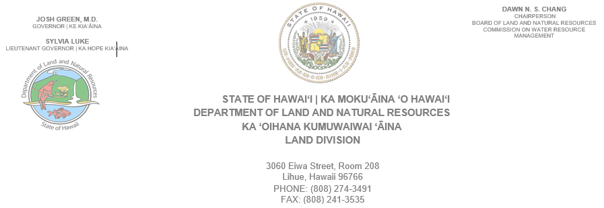
October 15, 2025

TO: Prospective Bidders

FROM: Reynold Lee, Acting District Land Agent
Department of Land and Natural Resources, Land Division

SUBJECT: Irrigation Contractor to operate and maintain the East Kauai Water System located on a portion of government lands within the drainage basins of the North Fork Wailua River and Kapaa Stream, Kawaihau, Kauai, Tax Map Key: Various.

Please submit a quotation to operate and maintain the East Kauai Water System for a period of 6 months. The area will include the existing irrigation water diversion and transportation infrastructure system including diversions on the Kapaa Stream and, Wailua Reservoir and Aahoaka: the Wailua and upper Kapahi Reservoirs; and related transmission and lateral ditch lines which are in working order. The winning bidder shall be responsible for the operation, repair and maintenance of irrigation water diversions and transportation system limited to addressing only public health and safety issues and preserving the ability of the system to divert and transport water in the future. Bidder must be a licensed irrigation contractor in the State of Hawaii. No diversion of water for irrigation or other commercial purposes will be allowed. Please see attached Detail Sheet for maps and more detailed instructions.

NOT included are the non-operational parts of the system in the Kapaa area which have been abandoned or are not currently in working order.

Please submit your fee quote online by 2:00pm on Octobert 23, 2025, to qualify as a prospective bidder for this project.

Vendor compliance will be conducted via Hawaii Compliance Express (HCE). Compliance is required from the successful bidder prior to awarding project and commencement of work activities. It is the responsibility of the vendor to ensure they are registered with HCE and their information is updated and accurate.

SCOPE OF WORK: See attached Detail Sheet.

- Supplying water throughout the active ditch system
- Manage the Wailua and Upper Kapahi Reservoirs
- Maintain the ditch intakes
- Maintain the vegetation on the dams to meet current standards
- Keep the ditch system clear of blockages and cut back overgrowth
- Complete routine inspections of the system
- Monitor dam water levels and manage water to maintain safe target levels
- File reports as required
- Keep the system secure

All potential bidders should conduct a field inspection of the irrigation system in order to determine that they are able to operate and manage the system to serve the purposes noted above. Potential bidders should have knowledge of the ditch and reservoir system and be capable of maintaining these systems during large storms and flood events.

Should you have any questions regarding the above, please give me a call at 274-3491, fax at 241-3535, or email at reynold.km.lee@hawaii.gov. Mahalo!

